Project 3-2: Tip Calculator

Objectives
Use concepts from Chapter 3 to complete Project 3-2

Description
Create a program that calculates three options for an appropriate tip to leave after a meal at a restaurant.

Requirements
- The expected output image provides the format for the program output.
- The amount of the meal is entered by the user.
- The program should calculate and display the cost of tipping at 15%, 20%, or 25%.
- The program should round results to a maximum of two decimal places
- Assume the user will enter valid data

Expected Output
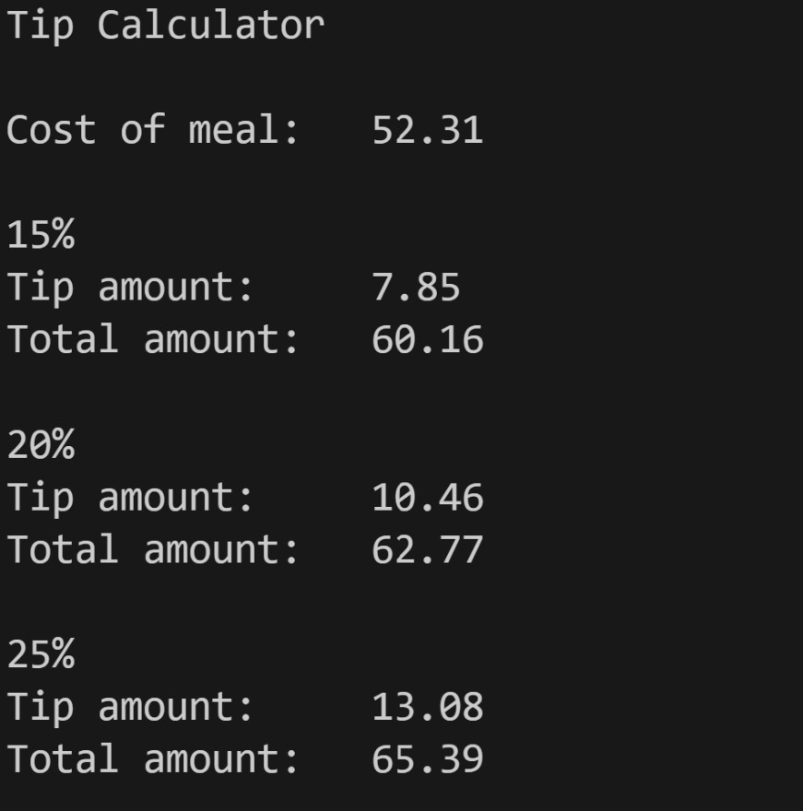

Grading Criteria
File naming convention | 5
Comments (Minimum file header comments and interior code) | 15
Use of input() function | 10
Use of F-String and/or round() | 20
Calculate all three percentages correctly | 20
Output format | 30
Code does not compile | -50
Total | 100

